**3.3**

**Set up & use access rights to enable other access/share files**

and shared a file with my tutor, to show I can allow access to others [sharing] access to my* *work,*

‘*Can view’ & ’can edit’,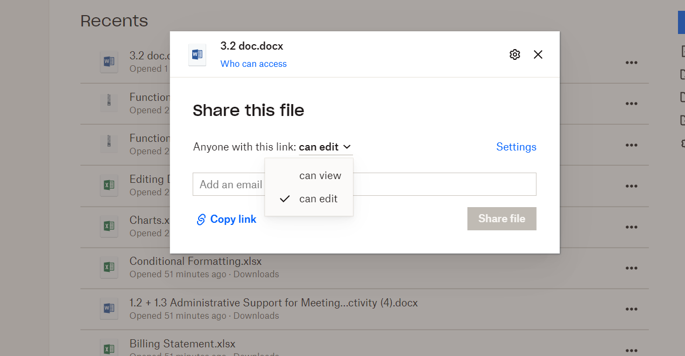*

*I can decide the level of rights the person I am sharing with, either to [Read Only], or [Read/Write].*

**GitHub**

In this collaborative application, the user can decide if their files can be accessed by everyone who has your GitHub e-mail address by selecting their repositories to be either **public** or **private.**

**Public** (kj, 2022)

Means the repositories in your account can be ‘read only’ to anonymous users, but they can not write over your files. The owner of the repository can give individuals ‘**privileges[1]**’ to ‘**push[2]**’ to your ‘**repo[3]’**

**Private**

Only accessible to you, unless you share with others, given permissions to and what level of rights you have allowed.

# Bibliography

kj. (2022, April 21). *Can antbody push to my project on github*. Retrieved from stackoverflow: https://stackoverflow.com/questions/17442930/can-anybody-push-to-my-project-on-github

1. Permission-right
2. Updates changes to your files, and sends to a remote repository where all can access the files
3. Repository- contains your files